**Session 2 (unit-1): Library functions and scope & lifetime of variables (storage classes)**

1. **WAP to implement any 5  funtions from string.h**

#include<iostream>

#include <string.h>

using namespace std;

int main ()

{

char str1[12] = "Siddharth";

char str2[12] = "Pandya";

char str3[12];

int len,comp ;

strcpy(str3, str1);

cout<<"strcpy( str3, str1) : "<<str3 ;

strncat(str1,str2,3);

cout<<"\n strncat(str1,str2) : "<<str1;

strcat( str1, str2);

cout<<"\n strcat( str1, str2): "<<str1;

len = strlen(str1);

cout<<"\n strlen(str1) : "<<len ;

strcmp(str1,str2);

comp = strcmp(str1,str2);

if(comp == 0)

{

cout<<"\n strings are equal ";

}

else

{

cout<<"\n strings are not equal";

}

return 0;

}

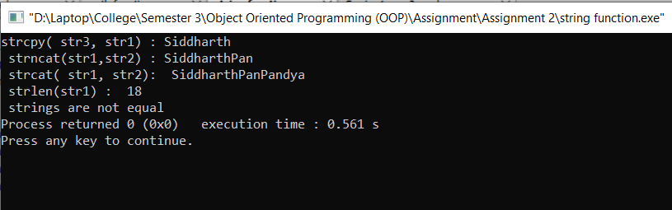

1. **WAP to implement any 5  funtions from math.h**

#include<iostream>

#include<math.h>

using namespace std;

int main()

{

float x;

cout<<"Enter the value of x:";

cin>>x;

cout<<"Ceil value for "<<x<<" is :"<<ceil(x)<<endl;

cout<<"floor value for "<<x<<" is :"<<floor(x)<<endl;

cout<<"square root value for "<<x<<" is :"<< sqrt(x)<< endl;

cout<<"sin value for "<<x<<" is :"<< sin(x) << endl;

cout<<"cos value for "<<x<<" is :"<< cos(x) << endl;

cout<<"log value for "<<x<<" is :"<< log(x) << endl;

}

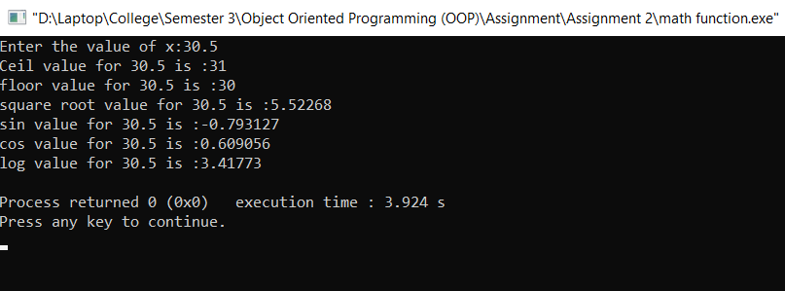

1. **WAP depicting working of storage classes in C++ (Automatic, External, Static, and Register)**

**Auto:**

#include<iostream>

using namespace std;

int sum(int n1, int n2)

{

auto int s; //declaration of auto(local) variable

s = n1+n2;

return s;

}

int main()

{

int i = 2, j = 3, k;

k = sum(i, j);

cout<<"sum is :"<<k;

return 0;

}

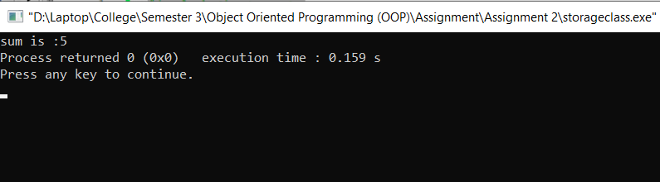

**Extern:**

#include <iostream>

using namespace std;

int g;

void print()

{

g = 10;

cout<<"g = "<< g;

}

int main()

{

g = 7;

cout<<"g = "<<g<<endl;

print();

return 0;

}

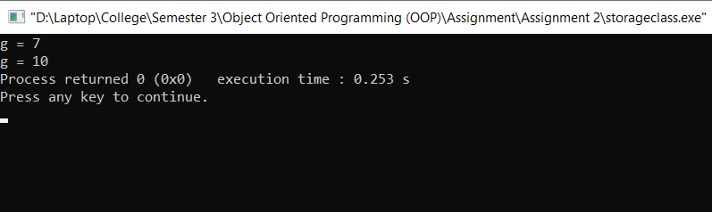

**Static:**

#include <iostream>

using namespace std;

static int g = 5;

void fn()

{

static int i = 0;

cout<<"g = "<< g--<<"\t";

cout<<"i = "<<i++<<endl;

}

int main()

{

while(g >= 2)

fn();

return 0;

}

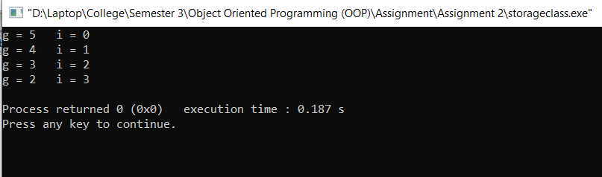

**Register:**

#include <iostream>

using namespace std;

int main()

{

register int n = 20;

int *ptr;

ptr = &n;

cout<<"address of n : "<< ptr<<endl;

cout<<"value of n : "<<n;

return 0;

}

